

Employment opportunities for disadvantaged Lancashire residents

Number of apprenticeships

Workforce planning and investment training employees

Business volunteers supporting academic institutions in curriculum development, careers information & education

Procurement and commissioning of local SME's, Social enterprises, and third sector organisations

Number of graduate placements, internships & work experience placements

**Student Profile: Gary Fisher,**

**Design Technician, HNC Construction**

Gary began his career sixteen years ago, in the Construction industry. He recently returned to college to study a HNC in Construction, with the goal to develop knowledge and skills that would take his career to the next level.

“As a Design Technician, I have found that my role is quite specialised and it can be difficult to find new learning opportunities.



**Delivering Social Value through Preston Western Distributor**

Scheduled to open early in 2023, this £200m road scheme is the biggest new road programme in the Preston, South Ribble and Lancashire City Deal.

In addition to increasing road capacity, promoting new housing and business development in the area, the scheme will deliver a wide range of social value benefits in each and every year of the construction period.

The project will generate employment and procurement opportunities for local people and businesses and support a number of invaluable apprenticeship and work placement opportunities for young people from the area. Work experience will also be geared toward providing pupils undertaking T-Levels with sector specific industry placements.

Lancashire Skills and Employment Hub will work with the contractor to broker links with appropriate organisations including the Enterprise Advisor Network and local schools, colleges to promote careers in engineering and construction through careers events, STEM activity and providing site visits and ‘taster days’.

**PWD Social Value Forecast**

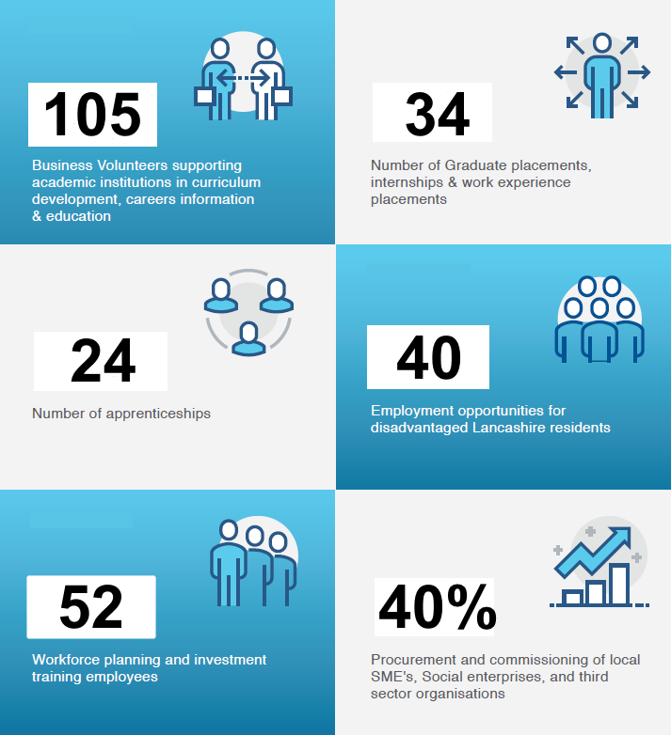

|  |  |
| --- | --- |
|  |  |



* City Deal & Local Authority update on regional residential and industry projects
* Employment & Skills Support workshops for SMEs
* Pathway to Construction Events (College learners to Apprentices)
* Meet the Buyer Events (Procurement support for SMEs)

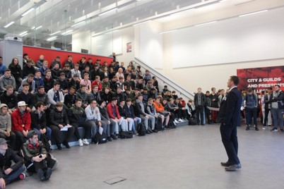

The Central Lancashire Construction Skills Hub was established three years ago with the aim of supporting the delivery employment, skills and procurement opportunities across Central Lancashire. Over that period the Hub has demonstrated its impact and value in delivering wide range of outcomes aimed at realising the local economic benefits of the City Deal investment.

These include:

**Creating Employment & Skills Opportunities for the community of Central Lancashire**

The HNC at Preston’s College has provided the perfect platform for me to develop my knowledge of a wide range of construction topics and demonstrate my capability to learn at a higher level. It has already proved invaluable in my current role and I know it will help me secure a promotion in the near future.”

**Appendix 3**

construction details needed to prepare construction drawings using the AutoCAD drawing package.

Commenting on Jacob’s appointment, Paul Dignan, Partner, said “we’re delighted to have appointed Jacob – he’s enthusiastic and is showing a good level of skill. We realise the importance of training up young staff and the apprenticeship route provides the best of both worlds with on the job training alongside the structure of a further education course.

As a regional firm, apprentices and graduates that work with us get a good level of exposure to all types of work, often working alongside our senior surveyors and having access to a huge amount of knowledge and support. We look forward to seeing Jacob progress within the firm and wish him all the best with the rest of his studies.”

Lea Hough is delighted to announce the appointment of its first apprentice. Jacob Wade joins the firm as an Apprentice Architectural Technician via a partnership between Lea Hough and Preston’s College. Jacob will work at Lea Hough alongside attending the college on a day release basis to complete his BTEC Level 3 course in Professional Construction and NVQ.

As an Apprentice Architectural Technician, Jacob’s role involves preparing drawings in relation to the building and construction projects that are project-managed by Lea Hough. Jacob will also undertake site visits, measured surveys and inspections of existing buildings to identify all









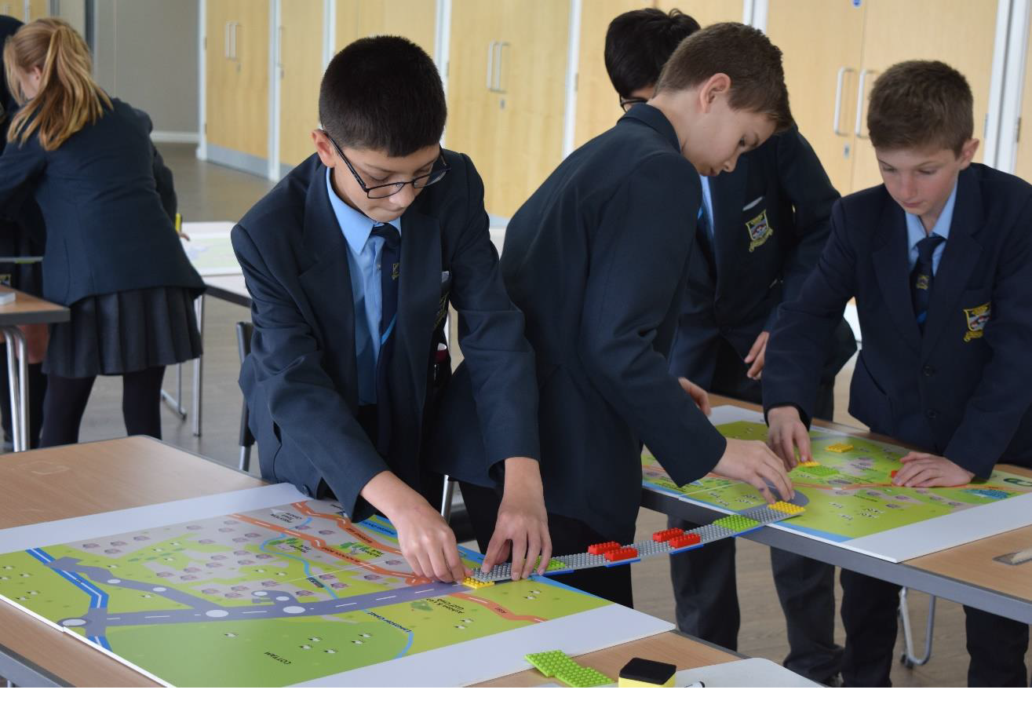

**City Deal – Skills and Employment update – November 2019**

**'Bridge the Gap' - Promoting STEM across City Deal schools**



In partnership with STEMFirst, the Skills Hub have developed the 'Bridge the Gap' game into a school based activity about City Deal and construction careers.

The 2 hour sessions aimed at Year 8 and 9 pupils helps shine a spotlight on the wide range of opportunities in STEM and construction.

The activity was bought by businesses and post 16 education providers, such as Preston's College, The Eric Wright Group and Future U, and delivered it in schools across the City Deal area.

During the 2018/19 academic year the programme succeeded in engaging with a 3,560 pupils at 23 schools across the City Deal area to raise awareness about the STEM related career opportunities being generated across central Lancashire.

Recruitment of business volunteers from across the sector is underway to support future delivery and ensure the continued success of the programme.

***“I enjoyed hearing about STEM in the world around us – it made us think"***





Since August 2019, Phoebe Dennis – CSR coordinator for Bowmer and Kirkland (B+K), has been working as an Enterprise Advisor with the Lancashire Network and Our Ladies Catholic High School to support the school in developing their careers program.

As part of this work, Phoebe has had meetings with the senior manager at the school and the schools Enterprise Coordinator to develop a careers week which will be happening in January 2020 and will involve B+K staff getting involved in the delivery of some careers sessions.

In addition to assisting with strategic careers planning, Phoebe and Joe McEvoy, a Construction Trainee from B+K, have also had a practical role in supporting the careers program at the school through attending the schools speed networking event.

This event gave students the chance to interview employers

and learn about job roles and routes into employment.

**Enterprise Advisor Network – Bowmer and Kirkland and Our Ladies Catholic High School, Preston**



**UCLan Careers Festival**

Bowmer and Kirkland attended the UCLan Careers

Festival on the 5th November 2019. At the event Phoebe

Dennis (CSR Coordinator) and Jess Taylor-Booth (Quantity Surveying Degree Apprentice) spoke to UCLan students about roles and opportunities at B+K. Many students expressed an interest in visiting the UCLan SCUS construction site for a site visit which

B+K will organise in the New Year.



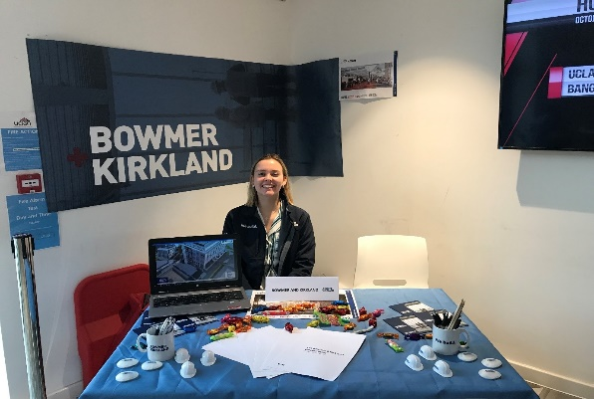

**Educating the Future Construction Workforce**